**College of Nursing, Christian Medical College, Vellore**

Minutes of IQAC Core Committee meeting

**(naac/certpromeet025-22/10/2022)**

Date: **22.10.2022,** **10.00am** Board Room

Chairperson: **Dr. Vathsala Sadan, Dean, College of Nursing, CMC, Vellore**

|  |  |
| --- | --- |
| **Members Present** | **Apology** |
| 1. Dr. Vathsala Sadan 2. Mrs. Alice Sony 3. Ms. Rajeswari Siva 4. Dr. Manoranjitham Sathiyaseelan 5. Dr. Vinitha Ravindran 6. Mrs. Sarah Emma Rosalind 7. Mrs. Ilavarasi Jesudoss 8. Mrs. Shandrila Immanuel 9. Ms. Anita Kiruba Jeyakumar | 1. Mrs. Reena George  2. Ms. Sophia Vijayanthan  3. Ms. Dorothy Singh  4. Mrs. Regina Xavier  Mrs. Emily Daniel |

The meeting commenced at 03.45pm with a prayer by Mrs. Ida Nirmal, add. Dy. Dean and Co-convener of Criterion II

The Chairperson welcomed the conveners and went through the minutes.

**Matters arising from the previous minutes**

**7/IQ/23/4/21-** The Chairperson informed that Mrs. Emily Daniel, Convener, Criterion V met the Dean and clarified data related queries on 27.05.2021. The Chairperson requested the conveners to organize the letter for data collection and submit it the Dean for further processing.

**10/IQ/23/4/21-** The Chairperson suggested including the clerical staff in each working team for easy data mobilization.

**Agenda**

**14/IQ/30/4/21- Presentation of working team and Key indicators**

The Criterion Conveners confirmed their working team members as follows:

|  |  |  |  |
| --- | --- | --- | --- |
| **CR.NO** | **CRITERION** | **CONVENER** | **TEAM MEMBERS** |
| I | Curricular Aspect | Ms. Reena George  Ms. Regina Xavier | 1. Ms. Annie Jerone 2. Ms. Deena David 3. Ms. Angeline Jeyarani 4. Ms. Joy Sherwin 5. Mr. Dani Paul 6. Ms. Shaly Selva 7. Ms. Anushya 8. Ms. Christina |
| II | Teaching – Learning & Evaluation | Dr. Manoranjitham S  Ms. Ida Nirmal | 1. Ms. Angeline Esther 2. Ms.Abijah Princy 3. Ms.Aruna.G 4. Ms.Harini 5. Ms. Rini wills |
| III | Research, innovation & Extension | Dr. Vinitha Ravindran  Mrs. Alice Sony | 1. Ms. Lillian Kisku 2. Mr. Dinesh Kumar 3. Ms. Angel Rajakumar 4. Ms. Ida Vimal 5. Ms. Malini- Secretary |
| IV | Infrastructure and Learning Resources | Ms. Sophia Vijayanthan  Ms. Dorothy Singh | 1. Ms. Jeni Chrystal 2. Ms. Ms. Jeba Terina 3. Ms. Hilda Mercy 4. Ms. Sheeba Paul 5. Ms. Jerlyn Mary 6. Ms. Meenatchi |
| V | Student Support and Student Progression | Ms. Emily Daniel  Ms. Sarah Emma | 1. Ms. Sheeba Nelson 2. Ms. Shalini Chandran 3. Ms. Sumathy J 4. Ms. Hepsi R 5. Ms. JeslinWills 6. Ms. Shekina Esther 7. Dr. Preethi Tabitha 8. Ms. Shalini Getzy |
| VI | Governance & Leadership | Ms. Rajeswari Siva  Ms. Ilavarasi Jesudoss | 1. Ms. Roseline Rhenius 2. Ms. Malini Rachel |
| VII | Institutional Values and Best Practices | Mrs. Shandrila Immanuel  Ms. Jenny S | 1. Ms. Esther Kanthi 2. Ms. Deborah 3. Mr. Charles Sathiyaoli |

**Criterion Conveners II & V presented Key indicators 1 & 2 and Criterion I, III, IV, VI, and VII did not present.**

**15/IQ/30/4/21- Orientation to NAAC Process for Conveners –08.05.2021- FLOW OF EVENTS**

The Chairperson reminded the conveners regarding the orientation to NAAC process which is

scheduled for 08th May 2021, between 08.30&10.30am.

The Chairperson also went through the flow of event planned as follows:

|  |  |
| --- | --- |
| **Topic** | **Speaker** |
| Opening Prayer | Mrs. Alice Sony, Deputy Dean |
| Overview of NAAC processing and objective of this orientation Program | **Dr. Vathsala Sadan**,  Dean, College of Nursing, CMC, Vellore |
| Criterion- I - Curricular Activities | **Ms. Reena Santhosh** |
| Criterion II – Teaching Learning & Evaluation | **Dr. Manoranjitham Sathiyaseelan** |
| Criterion III – Research, Innovations and Extensions | **Dr. Vinitha Ravindran** |
| Criterion IV – Infrastructure and Learning resources | **Mrs. Sophia Vijayananthan** |
| Criterion V – Student Support and Progression | **Mrs. Emily Daniel** |
| Criterion VI – Governance, Leadership and Management | **Mrs.Ilavarasi Jesudoss** |
| Criterion VII – Institutional Values and Best Practices | **Mrs. Shandrila Immanuel** |
| Concluding remarks | **Dr. Vathsala Sadan**,  Dean, College of Nursing, CMC, Vellore |

**16/IQ/30/4/21- Orientation PPT ready for use**

The Chairperson informed that a PPT is prepared by the IQAC office for the orientation programme. The Chairperson requested the conveners to check their emails for the same and requested them to refine, add and modify it accordingly.

**17/IQ/30/4/21- Suggestions:**

On opening the floor for suggestions the following issues were raised, discussed and resolved.

1. Mrs. Reena George suggested that it would be productive to have the Friday meetings weekly but in split groups. The Chairperson welcomed the suggestion and informed that a new schedule will be circulated regarding the dates.

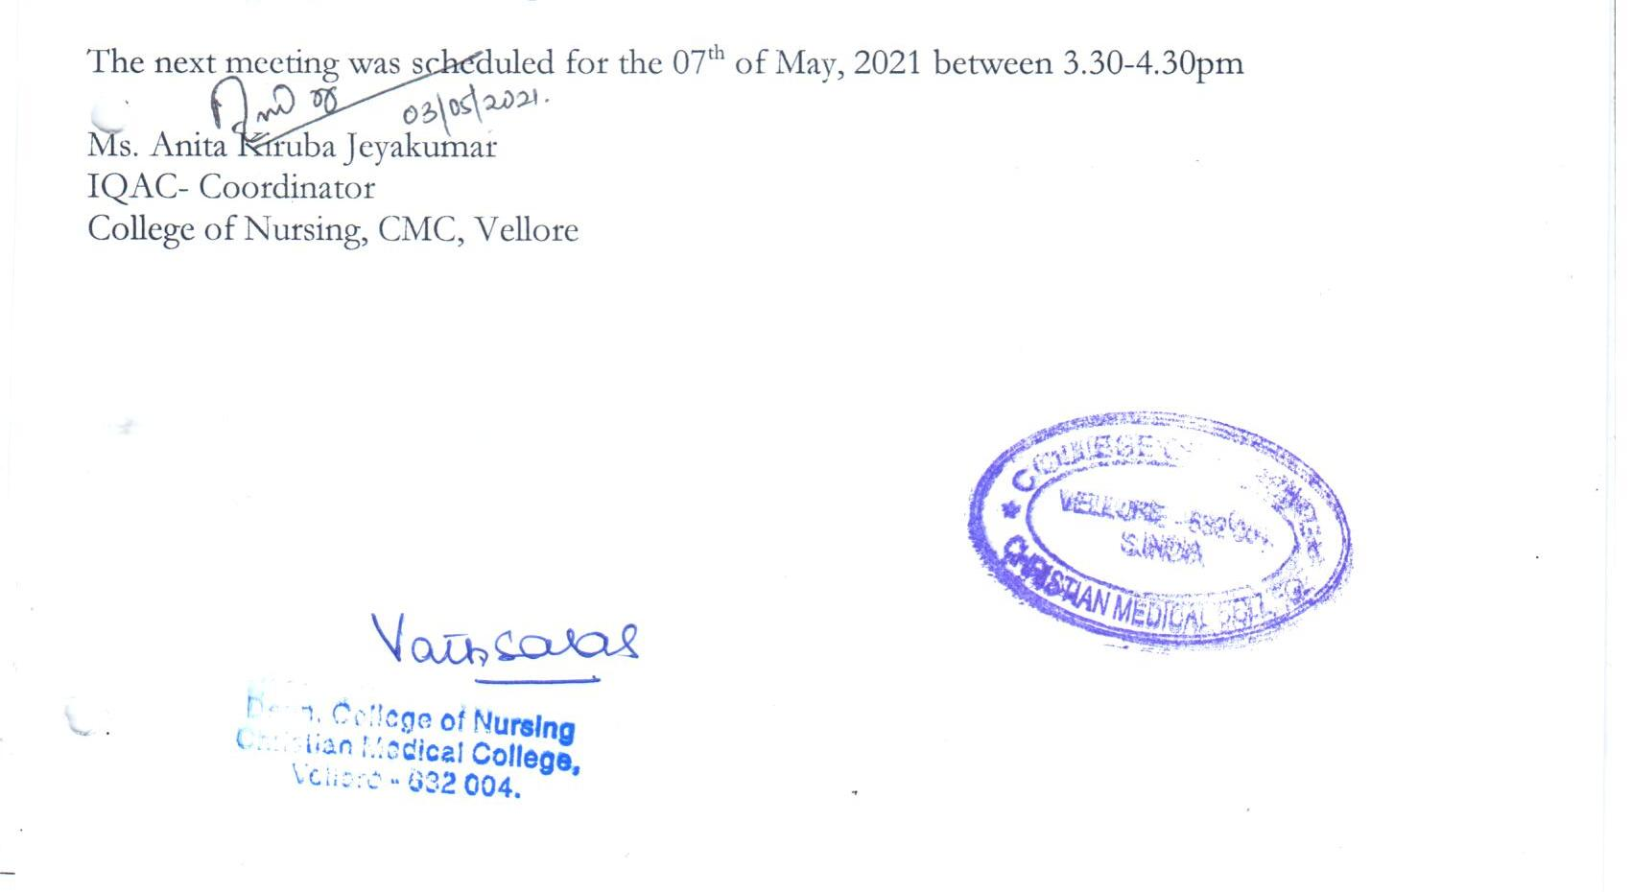The meeting adjourned at 4.45pm.